Emeka Nwosu

[emekacn@gmail.com](mailto:emekacn@gmail.com)

March 23, 2015

**A Nintendo Console Supported by Fans, Stifled by Fans:   
An Analysis of GameCube Sales Data**

The GameCube is a video game console that was released in the fall of 2001, after the popular Nintendo 64. It was discontinued in 2007, after the company diverted efforts to the next generation console, the Wii. The GameCube competed with Sony’s Playstation 2 and Microsoft’s Xbox during that time and is generally considered the least popular gaming console of the early 2000s despite the positive feedback from gamers who own one.

This project began last fall when I was learning how to use R (a programming language and software environment for statistical computing and graphics) version 3.1. R comes with a many data sets in the MASS (Modern Applied Statistics with S) package to aid users in the learning the program. However, I wanted a dataset focused on a subject I knew well and cared about to make learning more fun and so I could make more sense of what my results meant.

Fueled by nostalgia for one of my favorite consoles, I made a dataset with information on every GameCube game. I used R to analyze the data and kept a record of all the data manipulation, statistical analyses, and graphics I produced as I learned to use the program. The results of that work are presented here.

I began my work without any specific research question in mind. The goal was to get a better understanding of the GameCube’s library of games, look at the interaction between the variables, and delve deeper if anything seems interesting. My hope is that this work presents an interesting way to look back at a console some people, like myself, are very passionate about.

**Research Plan and Design**

The first part of the dataset was collected from VGChartz.com, a website that tracks video game and console sales. VG Chartz uses “a number of proprietary and ever-developing methods" to make estimates of how sales figures so the data is not as accurate as other existing sources (for example, the National Purchase Diary or Nintendo’s internal sales records). However, their data is publicly available so it was my only option.

I extracted data from their [list of GameCube games](http://www.vgchartz.com/platform/29/gamecube/) by saving the page as a PDF file and copying it to an Excel spreadsheet. This list provided the information I used to create the variables **game**, **release year**, **genre**, **publisher**, and **sales** (for all regions). I cleaned that dataset by removing double counted games, unreleased games, incorrect publisher information, and debatable genres. Details on all of my data cleaning activities can be found in the Code Book section.

Metacritic.com is a website that aggregates review scores for music, video games, TV, and movies. I used data from this website to create the variables **Metacritic score**, **ESRB rating**, **exclusivity**, and **multiplayer**. I entered all the data from this website by hand.

Any game information missing from VG Chartz and Metacritic or anything I felt needed verification was researched on IGN, YouTube, and other gaming websites.

I compiled the data into an Excel spreadsheet and exported the file to R, where I completed the remaining analysis and graphical representations. The graphs were coded in R markdown files and outputted to Microsoft Word with Knitr. I’ve also included some of the R code and output indented with a “##.” Every piece of code has been saved for verification.

**Variables and Descriptions**

* **Game:** Title of the game released on the Nintendo GameCube
* **Publisher:** Name of the company that published the game
* **Publisher 2:** Condensed recoded Publisher variable
* **Release Year:** Year the game was released on the GameCube
* **Release Year 2:** Condensed recoded Release Year variable
* **Genre:** Genre the game falls under
* **Genre 2:** Condensed recoded Genre variable
* **ESRB Rating:** Rating given by the ESRB
* **ESRB Rating 2:** Condensed recoded ESRB Rating variable
* **Multiplayer:** Number of players that can simultaneously play the game
* **Multiplayer 2:** Condensed recoded Multiplayer variable
* **Exclusivity:** Whether or not the game released exclusively on the GameCube
* **Metacritic Score:** Average review score collected by Metacritic
* **Sales N.A.:** Number of copies sold in North America (in millions)
* **Sales Eur:** Number of copies sold in Europe (in millions)
* **Sales Jap:** Number of copies sold Japan (in millions)
* **Sales Other:** Remainder of copies sold in other territories (in millions)
* **Sales Total:** Total number of copies sold worldwide (in millions)

**Descriptive Statistics**

**Console Sales**

There should be some clarity on how many units the GameCube sold compared to the competition and how many in each region. The number of copies games sell makes more sense when the number of consoles in the market and the way in which they are distributed is known. A game will never sell more copies than the number of consoles sold (unless some crazy people buy more than one) so we need to first see how many GameCube consoles were sold and how it compares to the competition, The Playstation 2 and Xbox. The Dreamcast was also part of that console generation, but it was discontinued about six months before the GameCube came out so I excluded it from my research. Sorry Sega fans.

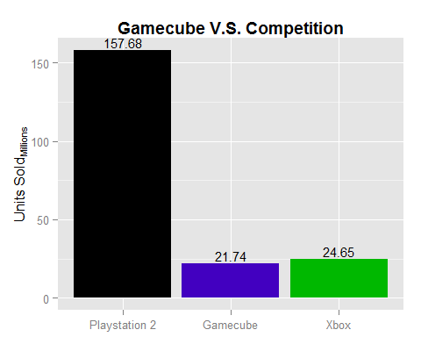

As much as people talk about how the GameCube didn’t sell well, it wasn’t too far off from the Xbox especially when compared to the Playstation 2. The 22 million that the GameCube sold is essentially the peak number that a game could potentially sell.

The sales number for each game is also separated by region. So again, the number of consoles sold in a region can be thought of as most a game could potentially sell in that region.

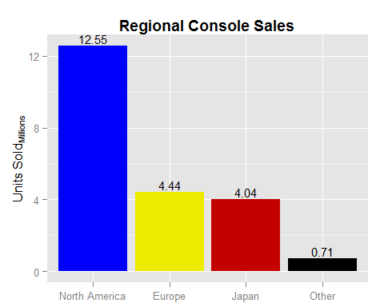

More than half of the consoles sales were in North America with Europe and Japan being almost equal. So when looking at game sales by region, it will be expected that North America sales to make up about half of the total.

With the console’s sales numbers known, we can look into the library of games. The rest of this section will focus on the descriptive statistics for each of the variables.

**Publisher**

The five companies with the most published games are Electronic Arts (92), Nintendo (56), THQ (48), Activision (47), and Konami (41). The yearly releases of FIFA, Harry Potter, Madden, NBA Live, NHL, and The Lord of the Rings games gave EA the edge of Nintendo in publishing games for their own console.

**Genre**

There are 137 sports games and 136 action/adventure games in the GameCubes library. EA has its yearly releases of sports games, but Konami also contributed many sports games including 10 in the *Jikkyō Powerful Pro Yakyū* series. Action/Adventure makes up a large portion because it’s so open that many games just fall into that genre. Below is the R output for the number of games in each genre.

summary(GCN2$Genre)

## ActionAdventure Collection Fighting Miscellaneous   
## 136 10 43 7   
## Music Party Platformer Puzzle   
## 6 15 80 15   
## Racing RolePlaying Shooter Simulation   
## 75 32 61 11   
## Sports Strategy   
## 137 15

**Release Year**

The most notable aspect of the graph is the drop in support during the year 2004 and again in 2006. The Wii came out in fall of 2006 so it makes sense for the number of games to drop around that time. Nintendo has a history of consoles that lack support from third-party publishers. The drop in support from 2003 to 2004 may be a result of that because they wouldn’t abandon their own console that far in advance of their next one.

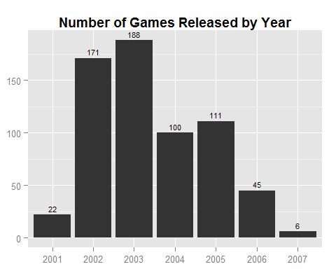

**ESRB Rating**

There is nothing too surprising about the distribution of games by ESRB rating. 304 games were rated Everyone, 34 were rated Everyone 10+, 207 were rated Teen, and 42 were rated Mature. Nintendo’s consoles are branded as being family friendly, yet it still had some M rated games in the library. There were not enough E10 and M rated games for any reasonable analysis so E and E10 games are grouped together while T and M games are grouped together.

**Multiplayer**

There is almost a perfectly even split between one, two, and four player games. 205 games are one-player, 204 are two-player, and 233 are four-player. The only three-player game is *Harry Potter and the Goblet of Fire* (which I grouped with two-player games in my analyses).

**Metacritic Score**

Below is a histogram and summary of the distribution of Metacritic scores. The average review score is 69. The lowest rated game is *Charlie’s Angels* and the highest is *Metroid Prime*. The “NA’s” are games not found on Metacritic.

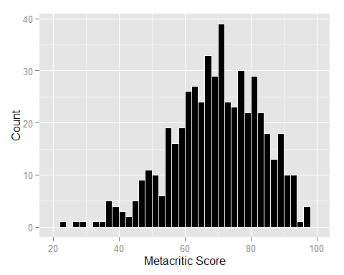

## Min. 1st Qu. Median Mean 3rd Qu. Max. NA's   
## 23.00 61.00 70.00 69.08 79.00 97.00 127

**Exclusivity**

153/643 (23.8%) games are exclusive while the remaining 490/643 (76.2%) games are also available on Xbox and/or PS2. Nintendo published 56 games which will all obviously remain exclusive. So when looking at third-party support, 97/587 (16.5%) are exclusive and the remaining 490/587 (83.5%) are multiplatform.

**Sales**

North America

-Mean sales total: 246,000

-Highest selling game: Super Smash Bros. Melee (4.41 million)

Europe

-Mean sales total: 78,000

-Highest selling game: Mario Kart: Double Dash!! (1.77 million)

Japan

-Mean sales total: 247,000

-Highest selling game: Super Smash Bros. Melee (1.39 million)

Worldwide

-Mean sales total: 356,000

-Highest selling game: Super Smash Bros. Melee (7.07 million)

**Bivariate Statistics**

This section focuses on how some the independent variables like publisher and ESRB rating relate to the dependent variables like Metacritic score and sales. For example, you will see if a game’s genre has any effect on how well it reviews or how many copies it sells. It may get a little repetitive with only two dependent variables that could potentially be affected by all of the remaining independent variables, but it was not too much work for me to check everything so I went ahead and did it.

**Genre**

Sports games had the highest average review score with a mean of 76, but nearly a third of those games were Electronic Arts’ sports games that had a mean score of 83. Without EA’s games, the mean review score for sports games drops to 71, around the means for the other genres. Even after removing the EA sports games and bringing the sports mean closer to the others, the ANOVA test showed a significant difference in mean review scores of games for different genres. This means that there is some sort of relationship between genre and review score. The test showed significance, but it still looks close enough that I would argue against it.

Action/Adventure   Fighting      Other    Platformer    Racing   RolePlaying     Shooter      Sports

67.85                         68.78           67.01    63.42             66.01     73.19                69.25          75.91

Games of different genres sold relatively the same on average. The ANOVA tests showed that the difference in sales of different genres was not large enough to be significant for any of the regions. Sports games sold the fewest copies, but that is a genre that is almost always multiplatform. So sales for those games are not going to be as high for an individual console. Fighting games performed the best on average in North America mostly because of success of *Super Smash Bros. Melee*. Role-playing games performed the best in Europe. The cumulative “other” genre sold best in Japan (racing games actually had a higher average, but there were very few games, one of them being *Mario Kart: Double Dash!!*).

**Release Year**

Games reviewed and sold relatively the same each year. The correlations between release year and sales for all regions were all negative, but still so close to zero that there really is not much of a relationship between the two. The slight negativity in the relationship with sales is probably just because the games released later have a little less time on the market and they get added to a larger established library of games to compete with. The slight negativity in the relationship with Metacritic score is caused by so few games being released in 2006/2007 with a number of them being lower quality ports of next gen games.

**ESRB Rating**

The ESRB rating had no effect on the way GameCube games reviewed. T/M rated games did review higher on average compared to E/E10, but only by a single point.

Game critics may not care about the ESRB rating, but the customers do. E/E10 rated games sold significantly better in North America, Europe, and Japan. The biggest difference is in Japan where E/E10 rated games outsold T/M games 2:1. Nintendo consoles are known for being family friendly. I wonder what that relationship looks like on the Xbox and PS2.

**Multiplayer**

One-player and two-player games reviewed pretty much the same with mean scores of 67 and 68. Four-player games had a 71 average review score which the t-test for difference in means showed to be significantly higher than the two-player games. It seems that the addition of multiplayer only really gets noticed by reviews if it’s four-player.

The distribution of means sales in all regions across the three levels of multiplayer showed an interesting pattern. Using North America as an example, the mean copies sold for one-player games is about 27,000. The mean for two-player games drops to about 21,000. Then the mean for four-player games rises to about 26,000. Every region follows this same pattern two-player games underperforming compared to one and four-player games. It doesn’t make sense for anyone to turn down a game because it specifically supports a maximum of two players, so the dip in sales must be because of what types of games end up supporting a maximum of two players games like the *Jikkyou Powerful Pro* and *Tom Clancy* series.

**Metacritic Score**

The correlation between Metacritic score and sales is positive in all regions which is expected. Better games sell more copies. The question I had is how strong is that relationship? The correlation between Metacritic score and sales is around a relatively weak .3 for all regions. So there are still plenty of lower quality games selling well and higher quality games selling poorly.

**Exclusivity**

The GameCube exclusives reviewed better than multiplatform games, but the difference barely missed the pre-determined critical region of .05 with a P-value of .059. This means that the difference in average review scores between exclusives and non-exclusives was very big, but not big enough to call attention to it. The difference is so small that a few missing Metacritic scores or sales numbers could be what kept it just outside the critical region. I would bet *1080 Avalanche* sold decently well, but there was no sales data for it.

Comparing exclusivity to sales seemed difficult to do accurately and it was. The exclusives should sell better on average than multiplatform games because their sales are spread around two or three consoles. Multiplatform games in this dataset can be GameCube/Playstation 2, GameCube/Xbox, or GameCube/Playstation 2/Xbox. The different consoles all had a different percentage of the market and all with different attach rates. I was not able to come up with a way to accurately compare these variables without data for Xbox and PS2 games.

**Nintendo and Third-Parties**

Every F-statistic calculated for the difference in mean Metacritic scores and sales had a hilariously small P-value, meaning there was a very low probability that the difference in means would be as extreme as they were. There are far too many publishers to perform a reasonable ANOVA test for the difference in means, even after reducing the smaller ones to an “other” group. I mentioned earlier that the exclusivity variable also did not work when compared to sales because exclusives will inherently sell less on an individual console.

This Nintendo and third-parties section overcomes those shortcomings in a way that is relevant for a Nintendo console. Gamers talk about how great Nintendo’s games are, how they only buy Nintendo consoles for their games, and how there are no third-party games on their consoles. So let us take a look into this in detail.

The data are separated by Nintendo and third-party. Then the third-party group is further separated into third-party exclusives and third-party multiplatform. These are the abbreviated names used in the R code.

Nintendo = nin

Third-party = tp

Third-party exclusive = tpx

Third-party multiplatform = tpm

**Third Party Exclusive vs. Third-Party Multiplatform**

There was no write up about the relationship between exclusivity and sales in the bivariate analysis. Exclusives will obviously sell more on a specific console because their total sales are not spread out between two or three consoles. When looking specifically at third-party exclusives compared to third-party multiplatform games, the difference in sales was much smaller and sometimes not significant for the different regions.

Exclusive games (including Nintendo) sell about 600,000 more copies than third-party multiplatform games equating to a significantly high t-statistic of 5.29 with a P-value of 4.969e07. However, third-party exclusives (excluding Nintendo) only sell about 110,000 more copies than third-party multiplatform equating to a t-statistic of just 1.89 with a P-value of .063.

This means that exclusives sell a lot more on the GameCube than multiplatform games like they should, but that is mostly because Nintendo’s games sell very well. When just looking at third party exclusives to multiplatform games, exclusives are expected to sell an extra 110,000 copies on the GameCube by staying exclusive to the platform.

The difference in quality was also taken into account. Exclusive games have the potential to look and run better than multiplatform games because resources are not spent in porting the game to different consoles. Using the Metacritic score variable to measure quality, the third-party multiplatform games actually outscored the third-party exclusives, but only by 2 points. The mean for multiplatform games also benefits greatly by the yearly releases quality EA sports games. When the number of those games is reduced, the means become more equal. This means that third-party exclusives are not seen as being “better” games and therefore are not getting a boost in sales on the GameCube because of the extra potential for quality.

**Nintendo vs. Third-Party**

Nintendo’s games out-reviewed and out-sold third-party games party games by a significantly large margin. Anyone who follows the video game industry probably expected this outcome.

Nintendo Metacritic score vs. Third-Party Metacritic score

**t.test**(x = nin$Metacritic.Score, y = tp$Metacritic.Score, na.rm=T)

##   
##  Welch Two Sample t-test  
##   
## data:  nin$Metacritic.Score and tp$Metacritic.Score  
## t = 5.452, df = 62.991, p-value = 8.855e-07  
## alternative hypothesis: true difference in means is not equal to 0  
## 95 percent confidence interval:  
##   5.915233 12.760553  
## sample estimates:  
## mean of x mean of y   
##  77.53061  68.19272

Nintendo total sales vs. Third-Party total sales

**t.test**(x = nin$Sales.Total, y = tp$Sales.Total)

##   
##  Welch Two Sample t-test  
##   
## data:  nin$Sales.Total and tp$Sales.Total  
## t = 5.6177, df = 50.367, p-value = 8.374e-07  
## alternative hypothesis: true difference in means is not equal to 0  
## 95 percent confidence interval:  
##  0.8303885 1.7543959  
## sample estimates:  
## mean of x mean of y   
## 1.5311765 0.2387843

(Difference in sales for the individual regions were also significant in Nintendo’s favor)

The correlation between Metacritic score and sales when separating Nintendo and third parties is worth taking a second look. Nintendo’s games sell and review so differently that the relationship between the two variables might be different for their games compared to third-party games. I mentioned earlier that the correlation between the two variables is a fairly weak .3. When looking specifically at third-party games, the correlation remains in the same area with a score of .31, but the correlation jumps up to .48 for Nintendo’s games. Keep in mind that there are many more third-party games than Nintendo games making the third-party correlation much closer to the correlation of the total set of games. This means that GameCube owners care much more about the quality or they are more likely to make purchasing decisions based on reviews when it comes to Nintendo’s games.

**Nintendo vs. Third-Party Exclusive**

Third-party multiplatform games must be excluded to perform a fair test comparing the total sales of Nintendo’s games to third-party games. Even though third-party exclusives did not sell significantly more than multiplatform games, exclusivity still mediates that relationship.

Nintendo vs. Third-Party exclusive sales

**t.test**(x = nin$Sales.Total, y = tpx$Sales.Total)

##   
##  Welch Two Sample t-test  
##   
## data:  nin$Sales.Total and tpx$Sales.Total  
## t = 5.0774, df = 55.989, p-value = 4.538e-06  
## alternative hypothesis: true difference in means is not equal to 0  
## 95 percent confidence interval:  
##  0.7266258 1.6736219  
## sample estimates:  
## mean of x mean of y   
## 1.5311765 0.3310526

Even after removing the third-party games that will sell fewer copies, Nintendo’s games still sell significantly better.

The correlation between Metacritic score and Sales for third-party exclusive games is .43 which is much closer to the .48 score that Nintendo games got. This refutes the earlier conclusion that the GameCube owners care more about quality and review scores for Nintendo games.

**Support over the Years**

Looking back at the release year variable, there was a noticeable drop in support from the year 2003 to 2004. With the newly separated data, it is now possible to see what happened in better detail.

Third-party multiplatform games make up a majority of the game library, so the proportion of total releases was observed instead of the raw number. The purpose is to look at when the most and fewest number of games were released based on the total amount of games released throughout the console’s life cycle. Evenly sized bars means that a consistent number of games were released each year. Discrepancy in size shows a shift in the number of games released. Also keep in mind that 2001 only accounts for the last 4 months of that year so that bar should be much lower than the others.

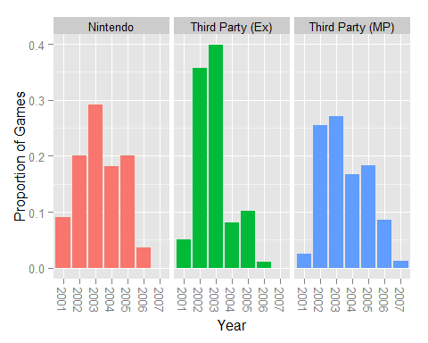

The main point is the difference in height between the 2003 bar and the 2004 bar. It drops for each group like the graph in the earlier section, but the largest drop is with the third-party exclusives. Nintendo continued publishing games because the company did not really have much of a choice. Third-party companies still decided the console was worth porting games to. It was the third-party exclusives that were lost in 2004. Exclusives did not sell that much more on the GameCube as shown in the earlier t-test. By 2004, third-party companies were done missing out on extra revenue they could get from the Playstation 2 and Xbox audiences.

**Metacritic Score and Sales**

The relationship between these two variables deserves another look because it changed after separating out the different groups. It was first believed to be a weak relationship with a correlation coefficient of about .3, but that relationship is much stronger with the exclusives in the .4 to .5 range.

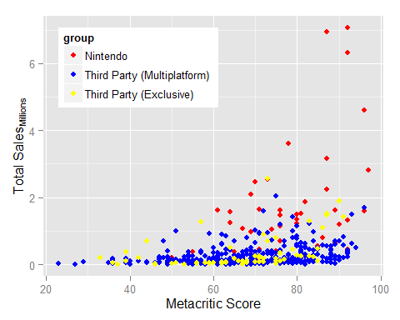

The Multiplatform games (blue points) make up the majority of the library of games. It is also expected that they make up the majority of the lower portion of the graph as their sales total sales are cut by some fraction by being multiplatform. There is still a positive relationship that can be seen with a few of the higher rated games rising above the pack, but there are still many more quality games that didn’t sell well which weakens the relationship (the blue points in the bottom right corner). Some of those are yearly releases of sports titles from Electronic Arts that are released yearly and maintain a high quality, but are not popular among GameCube owners. It is also possible that people who owned multiple consoles that generation bought those sports games on PS2 or Xbox.

Earlier, I mentioned that third-party exclusives do not sell significantly better than the third-party multiplatform games. This graph is visual evidence of that. Third-party exclusives are the yellow points that mostly overlap the blue points. The yellow points are basically in the same area as the blue points with the exception of a few higher rated games succeeding.

Nintendo’s games are the red points which are the only games that sold above the 2.5 million mark. There games perform so much better that *Kirby’s Air Ride* sold 1.62 million copies with a Metacritic score of 61 while *Bomberman Generation* sold 250,000 with a Metacritic Score of 81. That is just one example and is not the case for the entire population, but the graph clearly shows which of games sell and which games do not.

**Summary**

GameCube games reviewed and sold relatively the same regardless of the genre. You can find some good games in that library regardless of what type of games you are into and the consumers are open to playing anything.

The game drought many GameCube owners remember mostly a drop in third party third-party exclusives. Third-party companies were on board to take a chance with the console in its first two years, but low sales could justify continuing that type of support. The PS2 was selling a lot better and the Xbox did not have fans that were loyal to Microsoft the same way people are with Nintendo. It made more sense from a business standpoint not make a game exclusively for Nintendo’s console.

If a game is going to be designed with a multiplayer mode, go all out with 4 players instead of just 2. From my personal experience playing and talking to other GameCube fans, there is the single player *Metroid Prime* and *Resident Evil 4* experience or the multiplayer *Super Monkey Ball* and *Mario Party* experience. It is rare to see someone talk about a multiplayer game that is only for two people. The games people love the most on that console are the games that can be played with a group of friends.

GameCube owners care about review scores, exclusive games, and they care a little more so for Nintendo games. The GameCube was just not the console of choice for multiplatform games.

Exclusive games like *F-Zero GX* and *The Legend of Zelda: The Wind Waker* are thought to be amazing games perhaps because development resources were not spent porting the game to different consoles. Or maybe it is because Nintendo just knows how to make amazing games. Exclusive games reviewed much better than third-party games, Nintendo games still reviewed significantly higher than the third-party exclusives.

GameCube owners really like Nintendo games. Surprise! Unfortunately, that may have hurt the console in the long run. People are so focused on Nintendo’s games that very good third-party games get ignored. The idea that a good game will sell well is not very consistent on the GameCube for third-parties. Third-party exclusives do consistently sell better when the quality is there, but by enough especially when there are 150 million PS2s out there. People buy Nintendo consoles for Nintendo games, and there is little room for anything else on their platform.

**Conclusion**

The most significant thing I took away from this research is how Nintendo’s own games both helped and hurt them. Every Nintendo console benefits from having their exclusive games. They are very good, many gamers have a strong attachment to the brand, and you frequently hear “I’ll buy their console when the new Zelda and Mario come out.” However, it’s difficult for their sales to expand outside of that hardcore Nintendo audience because other companies can’t compete with them on their own hardware even when they put their full effort in an exclusive game. This leads to fewer games and negative perception of their console.

The blue ocean strategy of behind the Wii makes a lot more sense after looking at the shortcomings of the GameCube. Some hardcore Nintendo fans felt betrayed when they focused on attracting different audiences instead appealing to their existing audience, but it was successful enough to get third-party companies making games for them again. Nintendo went from a console with very few games to a console with arguable too many games. The loyalty of Nintendo’s fans complicates their success as a company.

**Code Book**

The excel spreadsheet and all of the R code with output have been saved. Below is a list of the variables with their meanings and all modifications I made to the dataset.

**Variable List**

**Game**

Title of the game

**Publisher**

The company that published the game.

**Publisher 2**

Every company with fewer than 16 published games was grouped into “other.” This list includes:

3DO, Asmik Ace Entertainment, Atlus, BAM! Entertainment, Banpresto, BigBen Interactive, Codemasters, Crave Entertainment, D3 Publisher, Disney Interactive Studios, Eidos Interactive, Empire Interactive, Encore, Epoch, Game Factory, Global Star, "Gotham Games, Hudson Soft, Idea Factory, Ignition Entertainment, Infogrames Entertainment, Jaleco, JoWood Productions, Kemco, Kids Station, LucasArts, Mad Catz, Majesco Entertainment, Marvelous Interactive, Media Kite, Milestone, Natsume, NDA Productions, NEC Interchannel, NewKidCo, O3 Entertainment, Pin Change, Rage Software, SCi, Sunrise Interactive, Taito, Takara, Tecmo Koei, Titus, Tomy Corporation, Universal Interactive, Virgin Interactive, Wanadoo, Bros. Interactive Entertainment, Xicat Interactive, Zoo Digital Publishing

**Release Year**

Year the game released. (2001 – 2007)

**Release Year 2**

The GameCube released in fall of 2001 and support was almost non-existent in 2006 (The year the Wii released). So 2001 data was grouped with 2002. 2006 and 2007 data was grouped with 2005.

**Genre**

Genre of the game. (action/adventure, collection, fighting, miscellaneous, music, party, platformer, puzzle, racing, role-playing, shooter, simulation, sports, and strategy)

“Action” and “Adventure” games were grouped into one variable, “Action/Adventure,” due to inconstant labeling across different websites and vagueness in what defines the genre. For example, on VG Chartz, *The Legend of Zelda: Ocarina of Time* is listed as an action game, but *The Legend of Zelda: Ocarina of Time/ Master Quest* is listed as an adventure game.

**Genre 2**

Genres of games that were not highly represented on the GameCube were grouped into “other.” This list includes: Collection, Miscellaneous, Music, Party, Puzzle, and Simulation.

**ESRB Rating**

The rating given by the Entertainment Software Rating Board. These ratings assign an age restriction to the game based on its content. (E = Everyone, E10 = Everyone 10+, T = Teen, M = Mature).

**ESRB Rating 2**

The E10 is rarely used by the ESRB so it was grouped with E. There were also very few M rated games on the GameCube so they were grouped with T. ESRB Rating 2 is a dichotomous variable with E/E10 or T/M.

**Multiplayer**

Whether or not the game supports multiplayer. The number indicates how many people can play the game at once.

**Multiplayer 2**

*Harry Potter and the Goblet of Fire* is the only 3 player game on GameCube so it was grouped with 2 player games.

**Exclusivity**

Whether or not the game is exclusive to the GameCube. Any game that could also be bought on the Playstation 2 or Xbox is not exclusive. Games that are compilations or remakes of older games that appeared on different consoles are still considered exclusive as long as it was released before the GameCube released on September 14, 2001 and cannot be bought on the Playstation 2 or Xbox. Games that hade remakes on the later generation of consoles (Wii, Playstaion 3, Xbox 360) are considered exclusive if the remake released after 2007.

**Metacritic Score**

The average review score found on Metcritic.com (Scale is 0-100).

**Sales**

The number of copies sold. Sales are separated by region and the total sales worldwide. The sales number is calculated in millions. N.A. = North America, Eur = Europe, Jap = Japan, Other = other countries and the remainder to equal the total sales.

Sales figures were obtained on VG Chartz. Their data is a very close estimate, but is not 100% accurate. This is the best I could do not having access to NPD data. Any game that sold 0 copies was replaced with NA.

**VG Chartz**  
Vgchartz.com was used to collect data on the variables, game, release year, genre, publisher, sales. <http://www.vgchartz.com/platform/29/gamecube/>

**Changes Made to the Data**

* Dance Dance Revolution Mario Mix and Naruto: Clash of Ninja were counted twice. Once for the game and again for the Japanese version. I just combined the two into one observation for my data
* The One Piece games were titled “Shonen Jump’s One Piece…” and not simply “One Piece…” Different websites use different versions of the title. I used the version without “Shonen Jump’s.”
* Missing release dates, publishers, etc. were researched and filled in.
* World Series Poker, Cabela’s Dangerous Hunts: Ultimate Challenge, and Cabela’s Outdoor Adventures (2006), had their publisher changed from “Activision Value” to “Activision.”
* Games with sales value of 0 for a particular region are assumed to not have released in that region and are replaced with an NA value
* The “platform” genre was changed to “platformer”
* The game, Barbarian, was titled “Warrior Blade: Rastan vs. Barbarian” in Japan. There is almost no information on the game anywhere. It only released in Europe and Japan and must not have sold much.
* TDK Mediactive was acquired by Take-Two Interactive in 2003. All games published by TDK are grouped into Take-Two

**Games Removed from the Dataset**

* 2 Games in 1: The Incredibles + Finding Nemo - (Combo pack of two GameCube games and no sales data)
* 2 Games in 1: The SpongeBob SquarePants Movie/ Battle for Bikini Bottom - (Combo pack of two GameCube games and no sales data)
* 2 Games in 1: The SpongeBob SquarePants Movie/ Tak 2: Staff of Dreams- (Combo pack of two GameCube games and no sales data)
* Donkey Konga 1+2 Pack - (Combo pack of two GameCube games and no sales data)
* Metal Gear Solid 2: Sons of Liberty - (No proof of game releasing on the GameCube and no sales data)
* Puzzler World - (No proof of game releasing on the GameCube and no sales data)
* Nintendo GameCube Preview Disk - (Not a game and no sales data)
* Pokemon Coliseum Bonus Disk – (Bonus material, not a real game, and no sales data)
* Pure Evil 2-Pack - (Combo pack of two GameCube games and no sales data)
* Rayman 10th Anniversary - (Game differed based on region and platform. Only released in Metropolitan France and included Rayman3: Hoodlum Havoc and a DVD of Rayman: The Animated Series. Rayman 3 had already released on GameCube. Also no sales data)
* Resident Evil 10th Anniversary - (Combo pack of Resident Evil, Resident Evil Zero, and Resident Evil 4. Also no sales data)
* Super Monkey Ball 2-Pack - (Combo pack of Super Monkey Ball and Super Monkey Ball 2. No sales data)
* The Legend of Zelda - (Part of The Legend of Zelda Collector’s Edition and no sales data)
* The Legend of Zelda Collector’s Edition - (Bonus disc part of the 2003 GameCube Holiday Bundle for Club Nintendo. No sales data)
* Zelda II: The Adventure of Link - (Part of The Legend of Zelda Collector’s Edition and no sales data)
* The Legend of Zelda: Majora’s Mask - (Part of The Legend of Zelda Collector’s Edition and no sales data)
* The Legend of Zelda: Ocarina of Time - (Part of The Legend of Zelda Collector’s Edition and no sales data)
* The Legend of Zelda: Ocarina of Time / Master Quest - (Bonus disk when pre-ordering The Legend of Zelda: Wind Waker. No sales data)
* Dead Phoenix - (Canceled project)
* Deadlight - (Canceled project)
* Wizardry Empire III: Haoh no Keifu (Canceled project)
* Space Invaders EX – (Canceled Project)
* Wizardry Empire III – (Canceled Project)
* Bulletproof Monk – (Canceled Project)
* Cabela's Dangerous Hunts: Ultimate Challenge – (Only released on the Playstation Portable)
* World Championship Poker – (Only released on the Playstation 2. GameCube version was canceled)
* The Tower of Druaga – (Pre-order bonus for the Japanese version of Baten Kaitos)
* Chessmaster – (Canceled project)

**Corrections in Publisher**

* Phantasy Star Online Episodes I & II change publisher from Infogrames Entertainment to Sega
* Pac-Man vs. Change publisher from Electronic Arts to Namco
* Sonic Mega Collection change publisher from Infograms Entertainment to Sega
* Lego Star Wars: The Video Game change publisher from Eidos to LucasArts
* Baten Kaitos: Eternal Wings and the Lost Ocean change publisher from Nintendo to Namco Bandai Games
* Tales of Symphonia change publisher from Nintendo to Namco Bandai Games
* Super Monkey Ball change publisher from Atari to Sega
* Super Monkey Ball 2 change publisher from Atari to Sega
* Pac-Man World 2 change publisher from Nintendo to Namco

**Changes in Genre**

* Bomberman Jetters- Puzzle to Action/Adventure (to match the genre of other Bomberman games and what is shown on other websites)
* Dance Dance Revolution: Mario Mix- Simulation to Music
* Star Wars Rogue Leader: Rogue Squadron II- Simulation to Shooter (Simulation Games are going to be grouped with ____ which is farther from what Rogue Squadron is. Also Action/Adventure had more than enough already. Also some sites had it as a shooter. Also all you do in that game is shoot things. Also Star Fox Assault is classified as a shooter and its very similar)
* Star Wars Rogue Squadron III: Rebel Strike- Simulation to Shooter (Same reasons as Rogue Squadron II

**Metacritic**

Metacritic.com was used to collect data on the variables, Metacritic score, ESRB rating, exclusivity, and multiplayer. Games with missing information were researched on various websites such as youtube.com, playasia.com, IGN.com, and a google images search for the box art.

* Tales of Symphonia was released on ps2 in japan about a year after the GameCube version, but I still gave it exclusivity anyway because it was only in one region